附表

托里县历史遗留矿山自然恢复图斑基本情况表
序号 | 图斑编号 | 地理位置 | 中心坐标 |  | 图斑面积  （m²） | 后期管护单位 | 图斑影像
 |  |  | 经度 | 纬度
1 | ZJ6542242021054001 | 多拉特乡 | 83°38′15.98″ | 46°17′27.91″ | 134696.73 | 多拉特乡 | 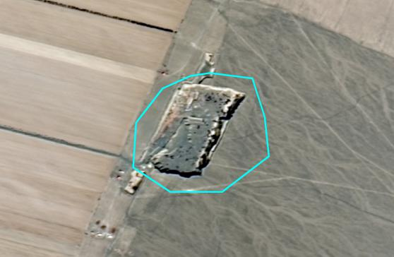
2 | ZJ6542242021003001 | 多拉特乡 | 83°49′52.19″ | 46°5′31.50″ | 36645.13 | 多拉特乡 | 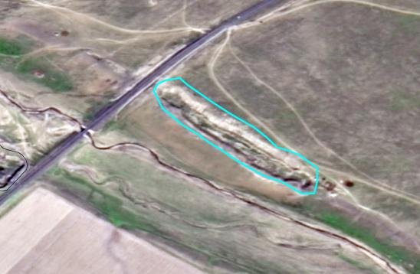
3 | CT6542242016000086001 | 哈图镇 | 84°56′32.24" | 45°44′15.84" | 14810.92 | 哈图镇 | 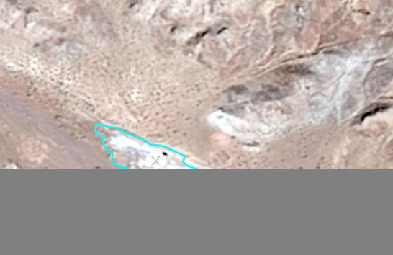
4 | CT6542242016000008001+1 | 托里镇 | 83°37′20.05" | 45°56′40.46" | 41702.65 | 托里镇 | 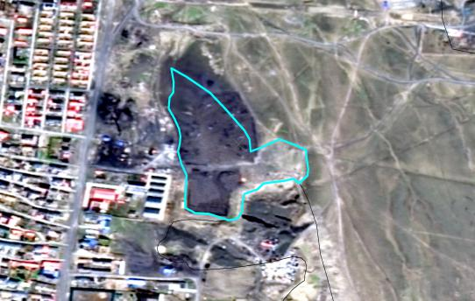
5 | CT6542242016000080005 | 铁厂沟镇 | 84°25′54.47" | 46°08′50.91" | 134839.88 | 铁厂沟镇 | 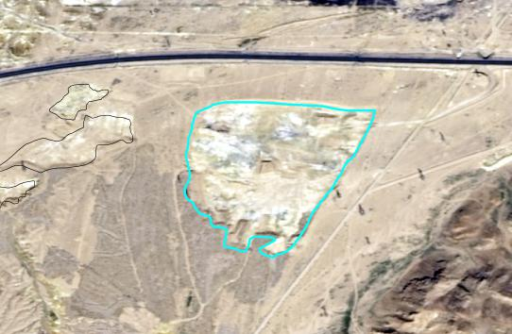
6 | CT6542242016000080004 | 铁厂沟镇 | 84°25′35.10" | 46°08′57.54" | 6991.89 | 铁厂沟镇 | 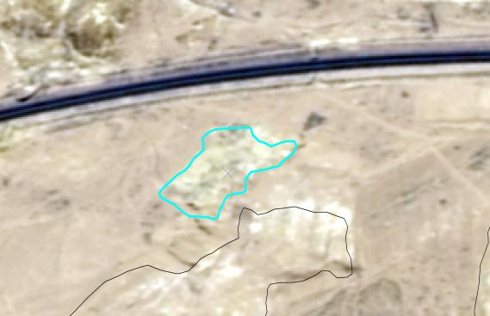
7 | CT6542242016000080003 | 铁厂沟镇 | 84°25′34.62" | 46°08′53.03" | 24383.19 | 铁厂沟镇 | 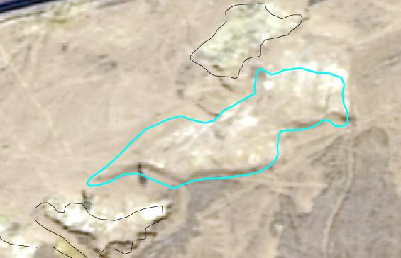
8 | CT6542242016000080002 | 铁厂沟镇 | 84°25′27.32" | 46°08′48.40" | 6800.53 | 铁厂沟镇 | 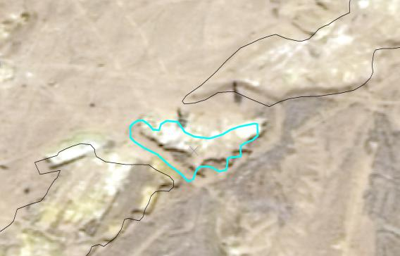
9 | CT6542242016000080001 | 铁厂沟镇 | 84°25′14.58" | 46°08′40.45" | 97695.67 | 铁厂沟镇 | 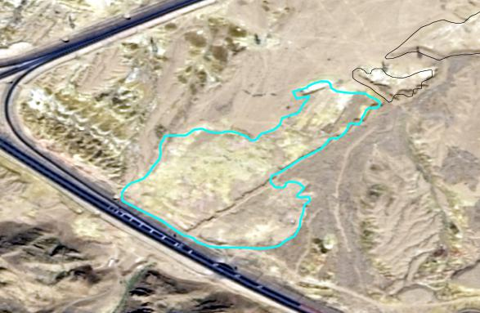
10 | C6542242014097130135572003+1 | 托里镇 | 83°34′38.54" | 45°57′08.13" | 30731.4 | 托里镇 | 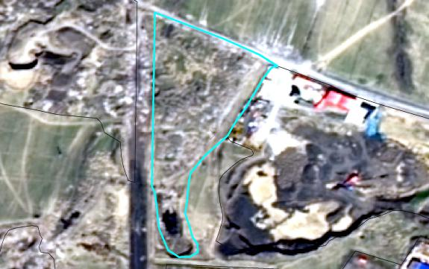
11 | ZJ6542242021004001+1 | 乌雪特乡 | 83°54′3.12″ | 46°6′42.33″ | 14998.88 | 乌雪特乡 | 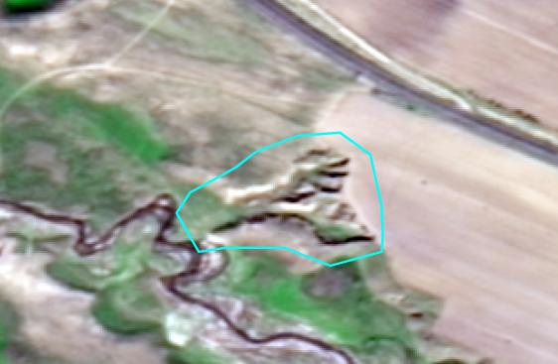
12 | CT6542242016000056001 | 乌雪特乡 | 84°16′18.21" | 46°11′52.09" | 41674.38 | 乌雪特乡 | 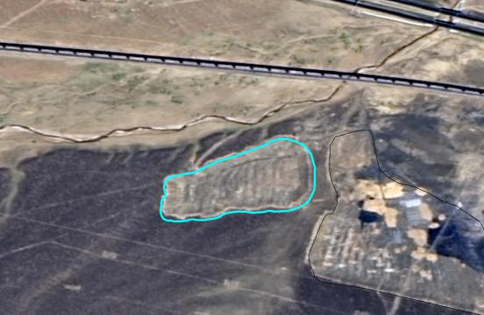
13 | CT6542242016000056002 | 乌雪特乡 | 84°16′31.81" | 46°11′47.40" | 101428.25 | 乌雪特乡 | 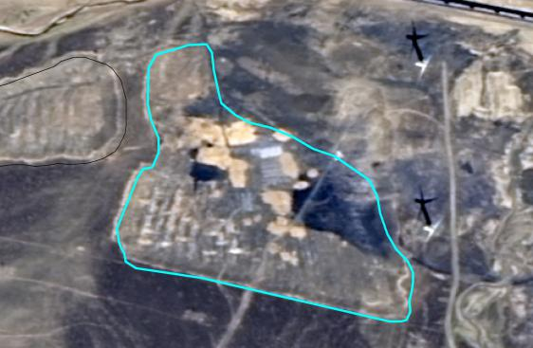
14 | CT6542242016000083001 | 铁厂沟镇 | 84°17′20.68" | 46°11′40.26" | 46602.55 | 铁厂沟镇 | 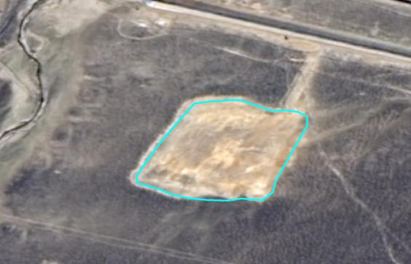
15 | CT6542242016000084001 | 铁厂沟镇 | 84°18′18.74" | 46°11′22.38" | 175102.44 | 铁厂沟镇 | 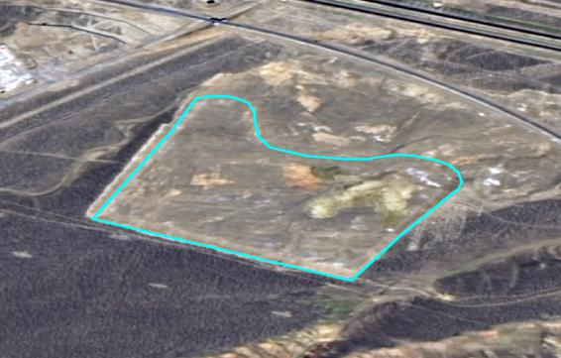
16 | CT6542242016000081003 | 铁厂沟镇 | 84°24′44.32" | 46°09′25.56" | 3071.19 | 铁厂沟镇 | 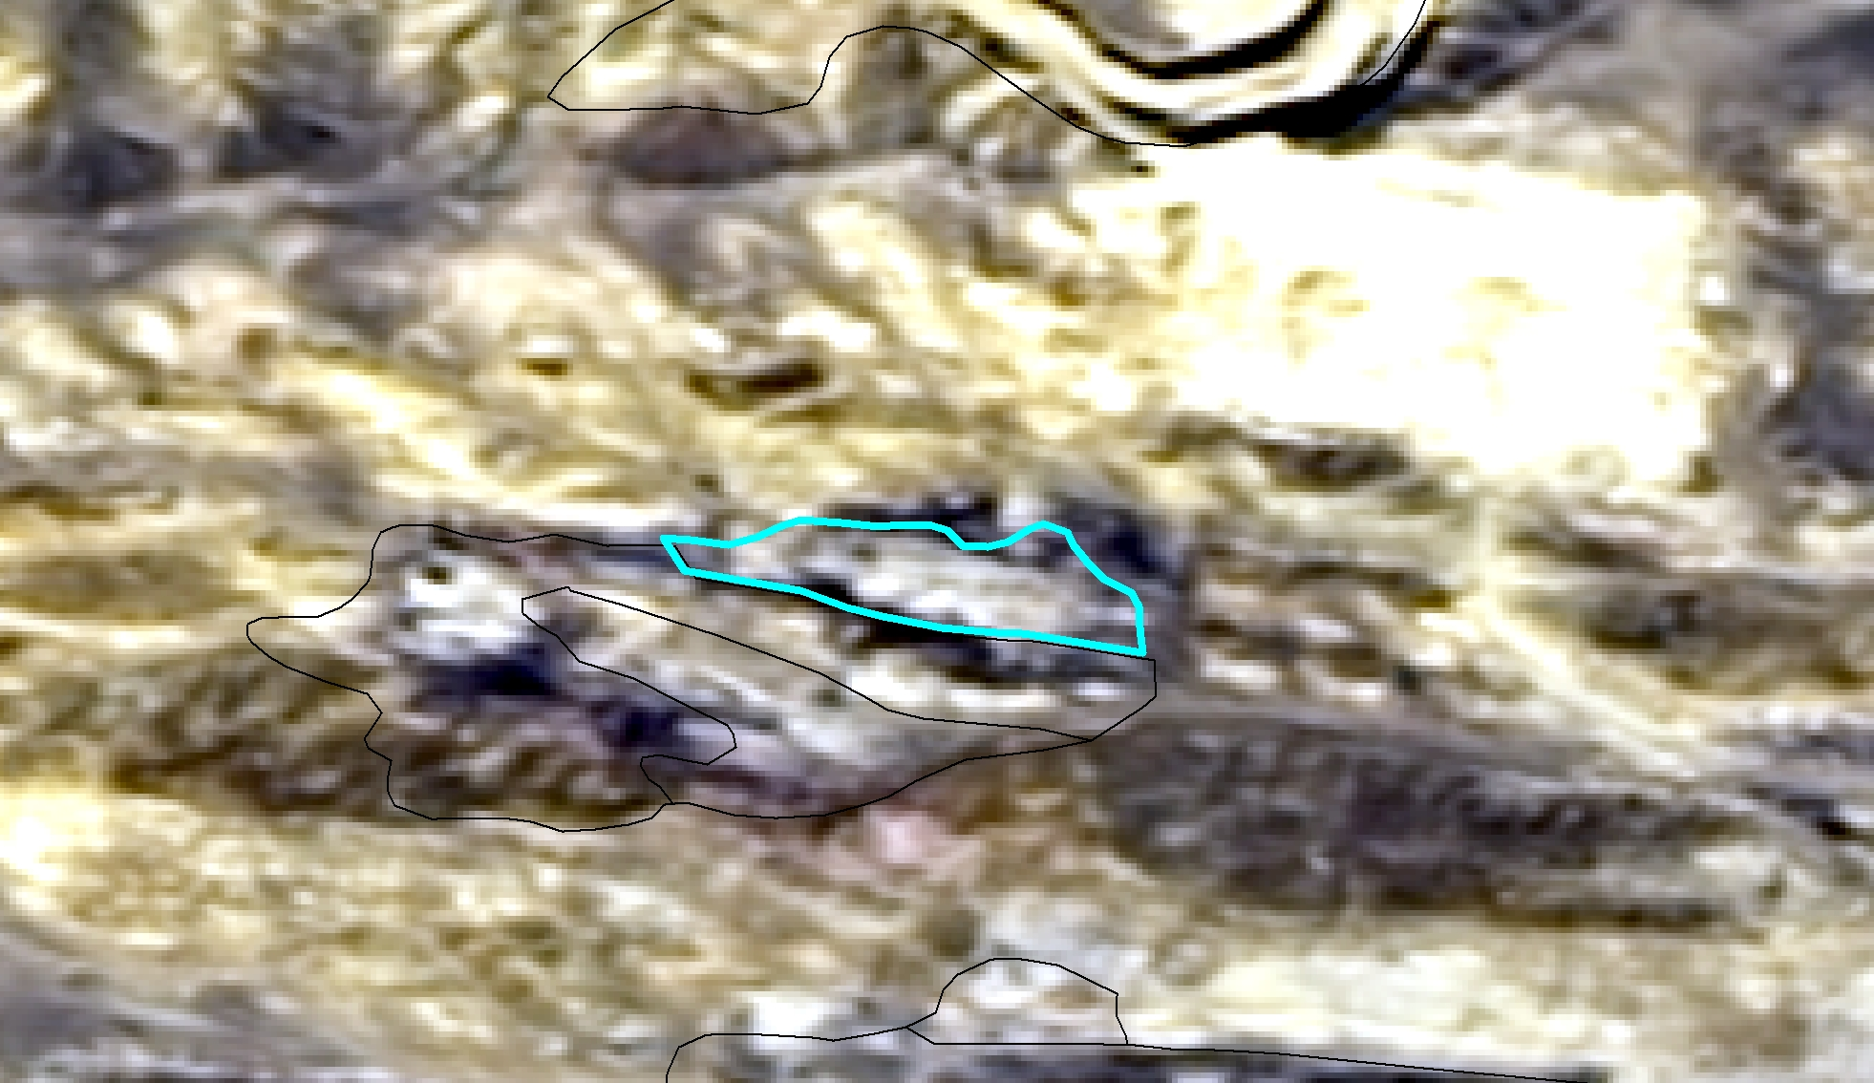
17 | CT6542242016000081001 | 铁厂沟镇 | 84°24′40.67" | 46°09′24.55" | 10539.62 | 铁厂沟镇 | 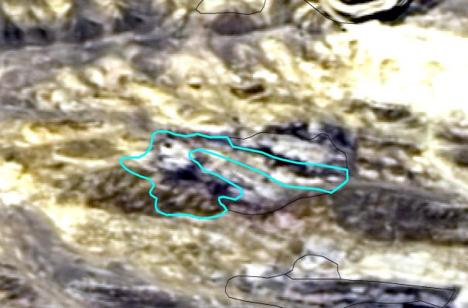
18 | CT6542242016000081010 | 铁厂沟镇 | 84°25′09.99" | 46°09′26.66" | 9764.04 | 铁厂沟镇 | 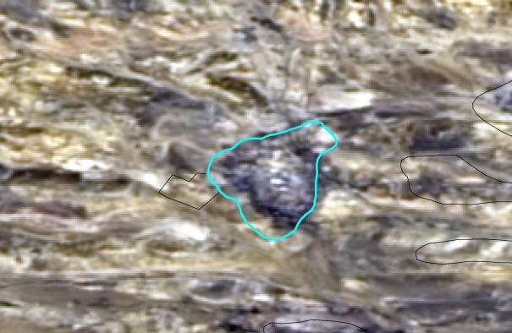
19 | CT6542242016000081014 | 铁厂沟镇 | 84°25′18.82" | 46°09′23.63" | 3378.23 | 铁厂沟镇 | 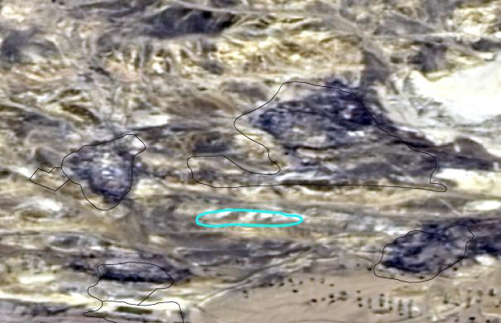
20 | CT6542242016000081011 | 铁厂沟镇 | 84°25′11.55" | 46°09′19.63" | 6461.28 | 铁厂沟镇 | 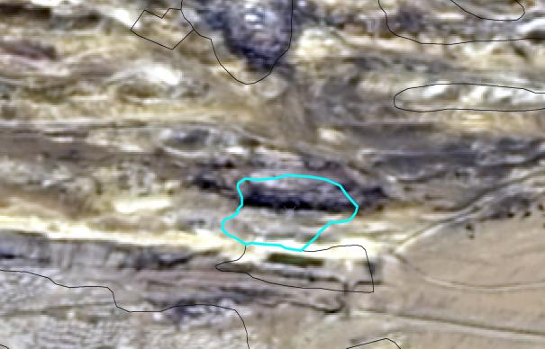
21 | C6500002010111120106995014 | 铁厂沟镇 | 84°32′13.54" | 46°10′47.37" | 230048.36 | 铁厂沟镇 | 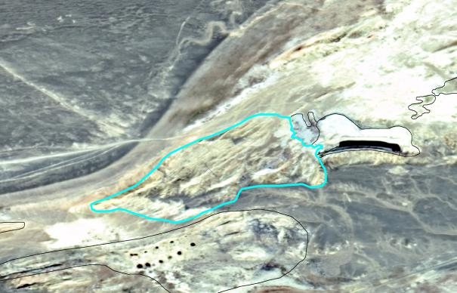
22 | C6500002010111120106995016 | 铁厂沟镇 | 84°32′24.96" | 46°10′25.19" | 3957.34 | 铁厂沟镇 | 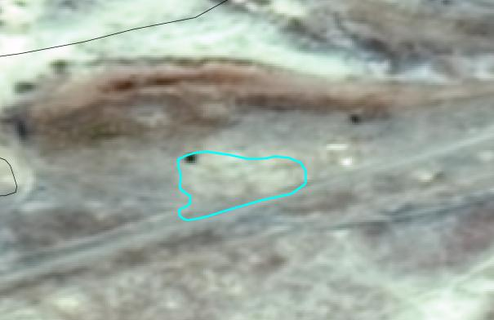
23 | C6500002010111120106995013+1 | 铁厂沟镇 | 84°32′06.97" | 46°10′34.04" | 96623.2 | 铁厂沟镇 | 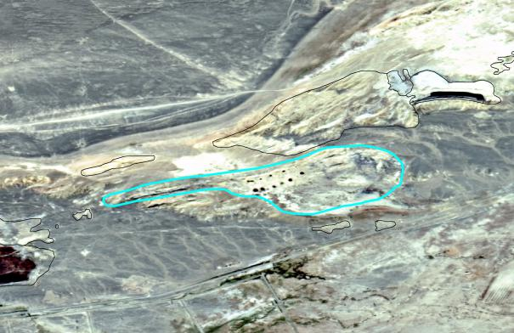
24 | CT6542242016000085001 | 铁厂沟镇 | 84°39′15.12" | 45°54′48.70" | 17296.2 | 铁厂沟镇 | 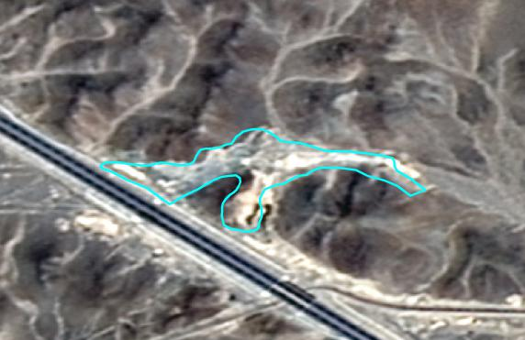
25 | ZJ6542242021023001 | 铁厂沟镇 | 84°54′45.06″ | 45°57′2.80″ | 27177.7 | 铁厂沟镇 | 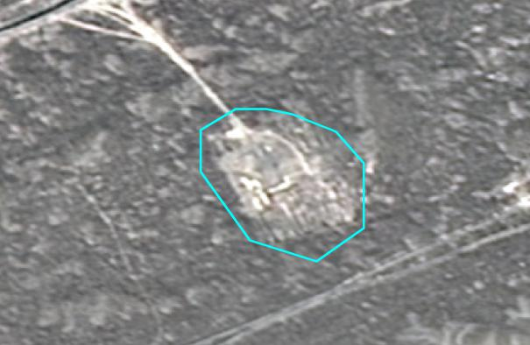
26 | ZJ6542242021022001 | 铁厂沟镇 | 84°57′8.51″ | 45°58′0.77″ | 26597.47 | 铁厂沟镇 | 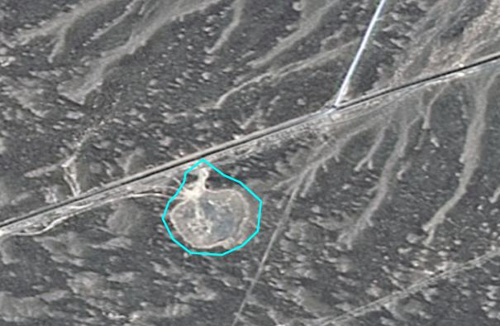
27 | CT6542242016000081015+1 | 铁厂沟镇 | 84°25′23.36" | 46°09′28.20" | 30492 | 铁厂沟镇 | 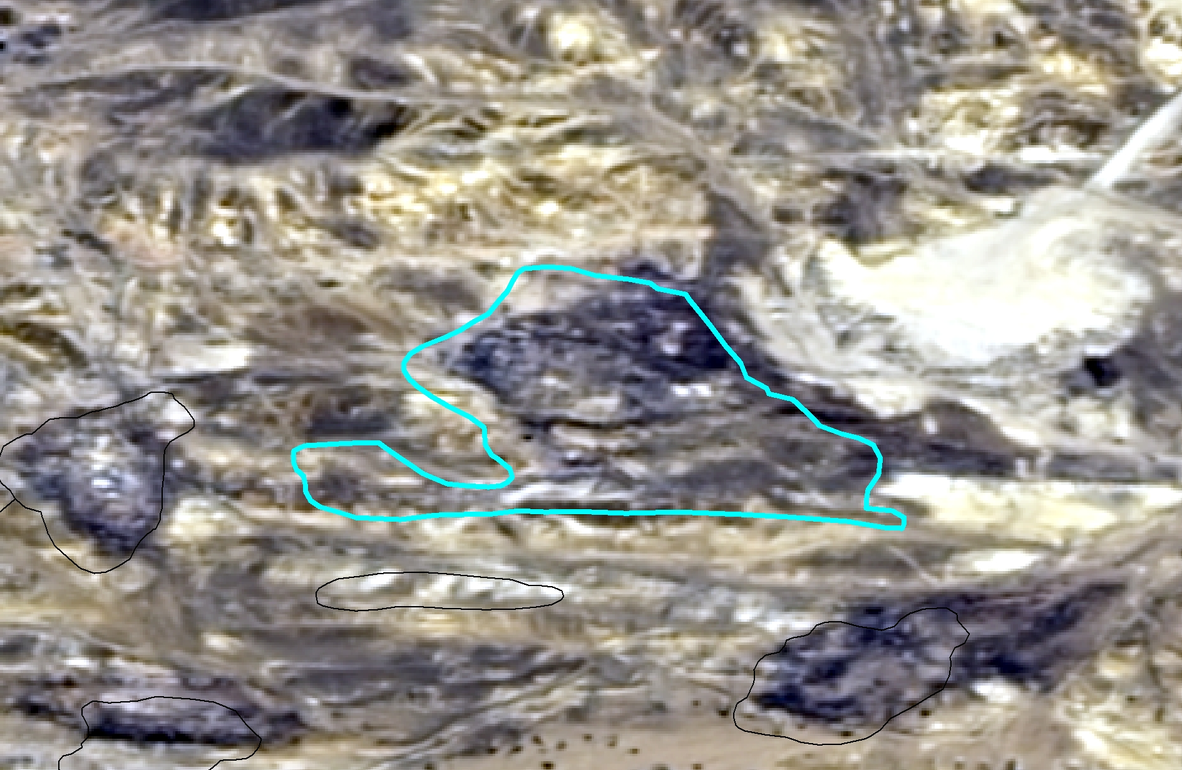
28 | ZJ6542242021039001 | 阿克别里斗乡 | 83°35′20.73" | 46°11′31.00" | 7254.83 | 阿克别里斗乡 | 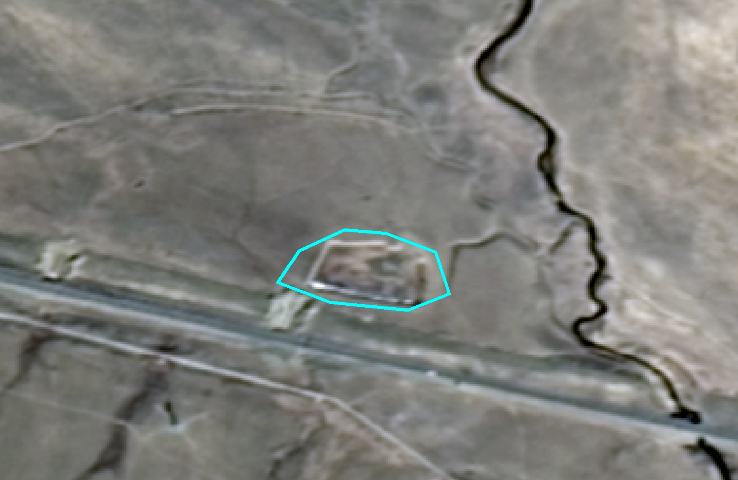
29 | CT6542242016000032001 | 铁厂沟镇 | 84°34′28.68" | 46°05′19.18" | 8547.75 | 铁厂沟镇 | 